AMES GRANT AWARD PROGRESS UPDATE: “Using Artificial Tissue to Design High-Fidelity Teaching Modalities – Preparing Medical Students for Clinical Training”

We have made significant achievements towards reaching the goal we outlined in our AMES grant application. Our primary objective was to design and test an artificial tissue suturing pad that we could distribute to medical students for practicing suturing technique. After experimenting with various tissues, tubing and sponge material, we designed a small tissue pad using platinum-cure silicone. We embedded a thin sponge and silicone tube into the center of the silicone pad and pressurized it with artificial blood (Figure 1). This provides a realistic oozing effect when an incision is made into the tissue. It was important for us to enable trainees to practice wound maintenance while suturing the laceration. Additionally, the artificial blood prompts trainees to learn sterile technique, another important teaching point in preparation for clinical training.

Figure 1: ASTEC suturing pad
To test the quality of our artificial tissue pad, we conducted a blinded comparative study with two commercially available suturing pads (Limbs & Things, Simulab). We recruited 10 third and fourth-year residents from the departments of surgery and emergency medicine to cut the artificial tissue pads and place two interrupted sutures. The residents were then asked to evaluate each of the suturing pads on a Likert scale of 1-5 for qualities related to the realism of appearance, and its response to incision and suturing. Results are shown in Table 1 below.
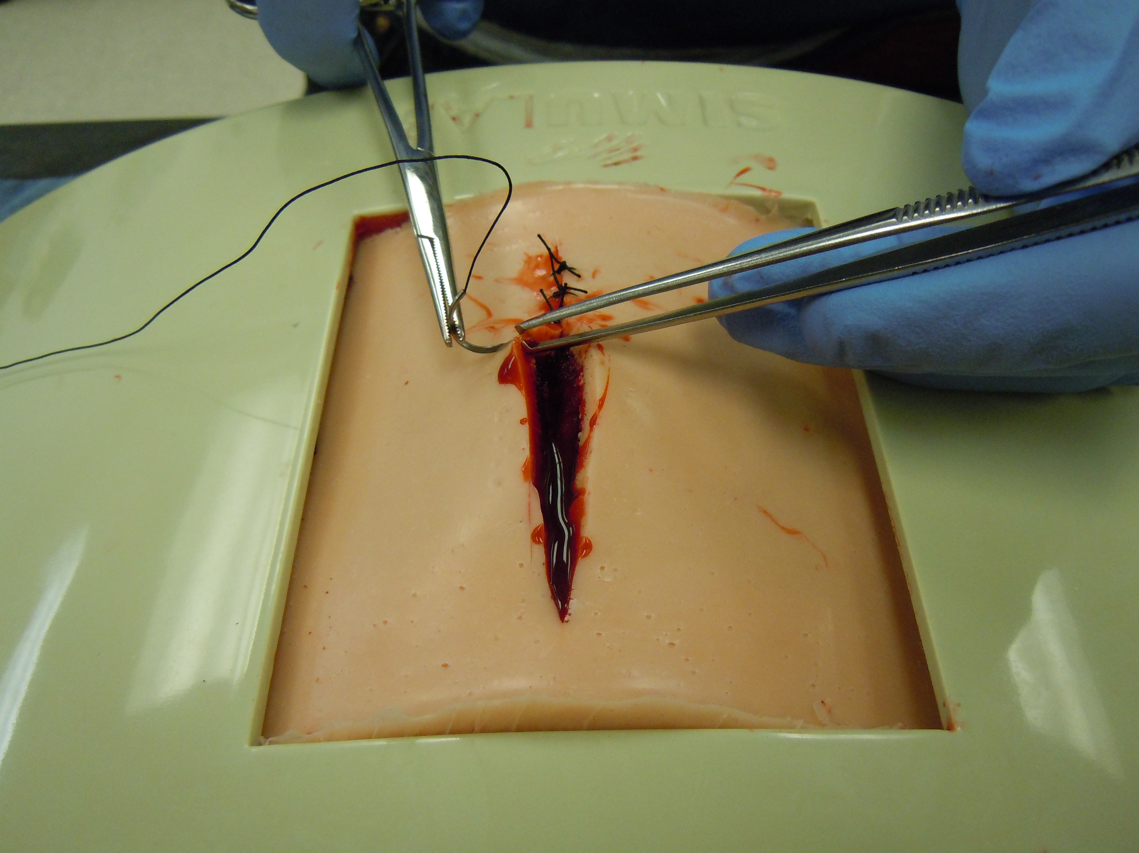

Table 1: Results from comparative quality assessment of suturing pads
Category | Quality | ASTEC | Limbs & Things | Simulab
Appearance | Pigmentation | 3.56 ± 1.13 | 2.11 ± 1.27 | 3.56 ± 0.88
 | Texture | 3.56 ± 1.01 | 1.78 ± 0.97 | 2.89 ± 0.78
 | Elasticity | 3.78 ± 0.97 | 1.78 ± 0.97 | 2.78 ± 0.97
Incision | Tension | 3.56 ± 1.13 | 1.78 ± 0.67 | 3.0 ± 1.0
 | Force | 3.56 ± 1.24 | 1.89 ± 0.78 | 3.0 ± 1.0
 | Bleeding | 4.11 ± 1.05 | 1.6 ± 0.55 | 2.0 ± 0.71
Suturing | Resistance | 3.44 ± 1.33 | 1.67 ± 1.0 | 3.11 ± 0.93
 | Hold suture | 4.0 ± 1.0 | 2.0 ± 1.12 | 2.89 ± 1.05
 | Tension to close | 3.78 ± 1.09 | 2.11 ± 1.05 | 3.11 ± 0.93

The results show that our suturing pad is more realistic to actual tissue than both commercially available suturing pads that are currently used as alternatives to chicken leg models. To make these suturing pads available to medical students for practice, we recruited several members of the UA Surgery Club and taught how to make the models. The Surgery Club is currently in the process of distributing them to interested members. Our learner contact hours for medical students practicing suturing have increased in the academic year 2012-2013 as compared to the previous year. We have also applied the lessons we learned in the design process of the suturing pad to other artificial tissue models. For instance, the design used to create the bleeding response was incorporated into a cardiothoracic surgery trainer we developed to practice emergent thoracotomies. This project was presented as a poster and a podium presentation at the International Meeting on Simulation in Healthcare in January 2012. We recently developed an abscess model that incorporates some of the qualities first featured in the bleeding tissue pad. This model will be presented at the International Meeting on Simulation in Healthcare in 2013.

In conclusion, we used the AMES grant award funding not only to accomplish our primary objectives but also to launch new projects. We thank you for your contribution to our efforts of providing the best medical training to our medical students.

Sincerely,

Hannes Prescher (on behalf of the entire ASTEC team)

